LMS Online Quiz –

Review Attempt/ Download Attempt

Teachers can review the detailed quiz attempts of the students and can download the individual attempts as well as all the attempts of a class as a single PDF file.
- To review an attempt of a student, click on “Review Attempt” link available for a particular student.

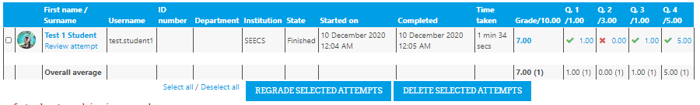

- Along with the quiz attempt summary, the detailed reports contain all marked answers and the time of attempt of each question.

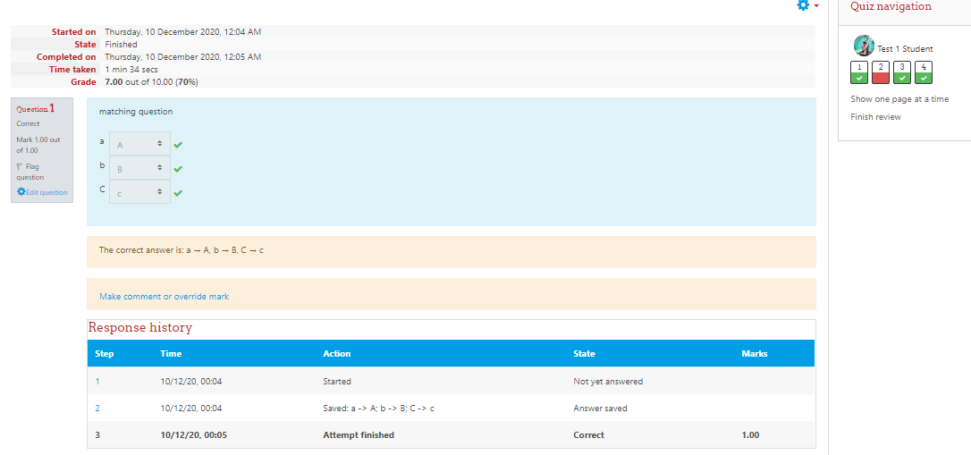

- In order to download the attempt, click on the “Actions menu” and select the “Export Attempts” link.
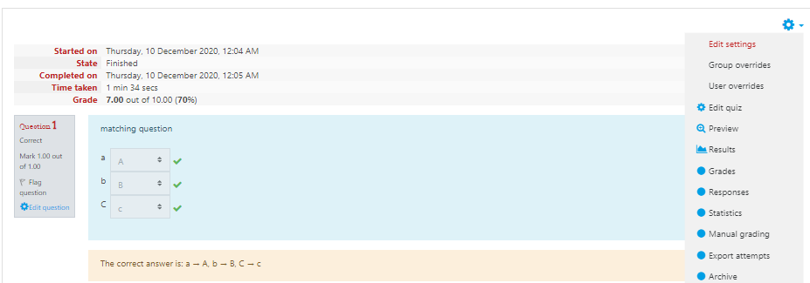

- Click on the review sheet and “Print” it as a PDF file.
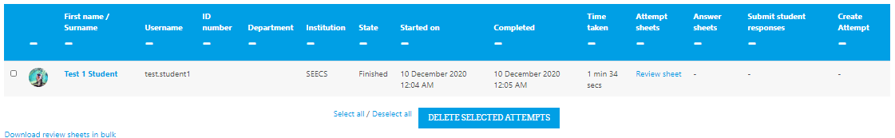

- In order to archive all attempts of a quiz, select the link “Archive” from the “Action menu” dropdown of the quiz.

- A single web page will appear displaying all attempts of the class, which can be saved as a single PDF file for archival purposes.

______________________

